Republic of the Philippines

BAGO CITY COLLEGE

Bago City, Negros Occidental

BAGO CITY ONLINE JOB PORTAL WITH SMART RECOMMENDATION AND GEOSPATIAL ANALYSIS

A Capstone Project Presented to the Faculty of

Bachelor of Science in Information System Department

Bago City College

Bago City, Negros Occidental

Philippines

In Partial Fulfillment of the Requirements for the

Degree of Bachelor of Science in Information System

Programmer/Developer

Palmes, Jesryl S.

Perocho, Seeger Alan J.

Romero, Janssen Rey E.

March 2024

Republic of the Philippines

BAGO CITY COLLEGE

Bago City, Negros Occidental

PROJECT COORDINATOR AND PROGRAM HEAD’S ACCEPTANCE SHEET

The Project Entitled

Bago City Online Job Portal With Smart Recommendation And Geospatial Analysis

After having been recommended and approved and is hereby accepted by the

Bachelor of Science in Information System Department of Bago City College,

Bago City, Negros Occidental

ANTHONY S. MALABANAN MIT, MIT-MATH

BSIS Program Head/Project Coordinator

March 2024

Republic of the Philippines

BAGO CITY COLLEGE

Bago City, Negros Occidental

**PANEL’S APPROVAL SHEET**

The Project Entitled

Bago City Online Job Portal With Smart Recommendation And Geospatial Analysis

Developers:

Palmes, Jesryl S.

Perocho, Seeger Alan J.

Romero, Janssen Rey E.

After having been presented and is hereby approved by the following member of the Panel

June 2024

**TABLE OF CONTENTS**

**TITLE**  **PAGE**

Acceptance Sheet

Approval Sheet

Acknowledgement.…………………….…………………………………………. i.

**Chapter I INTRODUCTION**

Context of the Study………...…………………………………………… 2

Historical Background…………………………………………………… 3

Statement of the Problem……………………………………………….. 4

Objectives of the Study……...…………………………………………... 5

Significance of the Study………………………………………………... 6

Scope of the Study…………..…………………………………………... 7

Limitations of the Study……..…………………………………………… 8

**Chapter II LITERATURE REVIEW**

Related Concepts………...………………………………………………. 13

Related Works……………………………………………………………. 15

Related Tools…………………………………………………………….. 17

Synthesis……...…………………………………………........................ 20

**Chapter III METHODOLOGY**

Model Base………...……………………………………………………… 22

Model Phase……………………………………………………………… 23

**Chapter IV ENVIRONMENTAL CONTEXT**

Organization………...…………………………………………………….. 29

Processes…………………………………………………………………. 34

Data………………………………………………………………………... 36

Technology……...…………………………………………..................... 40

Information………………………………………………………………… 42

**Chapter V REQUIREMENTS ANALYSIS AND SPECIFICATION**

Technical Requirements………...………………………………………. 46

System Facilities and Features…………………………………………. 51

Data Requirements………………………………………………………. 53

Information Requirements……...……………………………………….. 54

Functional Requirements……...………………………………………... 55

Management and Support Requirements……...……………………… 57

**Chapter VI DESIGN**

Architectural Design………...……………………………………………. 59

Process Design…………………………………………………………... 60

Use Case Diagram………………………………………………………. 61

Data Flow Diagram……...…………………………………………......... 62

Entity Relationship Diagram……...…………………………………….. 63

Database Design……...…………………………………………………. 64

Prototype Design……...…………………………………………………. 68

**CHAPTER I**

**INTRODUCTION**

The City of Bago is slowly seeing development with its old-fashioned ways of everyday work, from government offices and local firms. However, most establishments and firms are still lacking the use of automation to be able to handle the flow of information efficiently and accurately. To this day, there is yet to be an alternative developed for the people that resides within the city of Bago that can specifically provide and reduce unemployment that goes unnoticed nor is given attention. In a country with highly significant poverty rates, people will look for any job they can find to sustain their everyday needs, some even have to work for crumbs in order to survive.

Bago city is a 2nd class component city in the province of Negros Occidental with a population of roughly 247,867 based on the 2020 census, although it may sound pleasant but in reality many would still favor to work in other cities like Bacolod where the minimum wage is not as bad. Locals would often complain about the low salary that the city can offer, therefore considering to look for places that can provide a much comfortable sustainability, affecting livelihood and brings poverty that is widespread in our country.

**Context of the Study**

Traditional methods of job hunting are gradually being replaced by online platforms that offers convenience. The proposed study aims to develop a system for an online job portal tailored for the specific needs of the residents of Bago City. This portal will not only serve as a platform for job seekers to find employment opportunities but will also prove as a tool for individuals that have set of skills with the help and incorporation of smart recommendations and geospatial analysis features to enhance the job search experience.

The system is specifically made to tailor residents in a city scale to be able to give seamless insights and availability of what and where is the best possible suited job for individuals, instead of focusing on a larger scale where job for hire standards can scale high for employment, this study focused from a micro perspective matter at hand in order to control poverty from scratch and is able to run the most convenient top down solution for people with skills that are having trouble landing a job, undergraduates, and the unemployed.

**Historical Background**

Bago City, located in the province of Negros Occidental, Philippines, has a rich history dating back to the Spanish colonial period. The city was founded in the 18th century and has since grown into a bustling urban center known for its agricultural and industrial sectors. Over the years, Bago City has seen significant economic development.

The establishment of an online job portal in Bago City is made for modernizing the economy and providing opportunities for its residents. By embracing digital technology, the city can connect job seekers with employers more efficiently, fostering economic growth and prosperity for the community.

Through the online job portal, residents of Bago City can access a wide range of employment opportunities, from traditional industries to emerging sectors. This platform not only streamlines the job search process but also promotes inclusivity and accessibility for all members of the community.

**Statement of the Problem**

The limited use of modern recruitment practices in Bago City creates a challenging environment for both job seekers and employers. The following are the major problems faced regarding employment:

1. Limited visibility of local businesses.
2. Unemployment.
3. Mismatch between skills and job requirements.
4. Geographical barriers that limit access to job opportunities.

**Objectives of the Study**

To address the problems, in our study we have found solutions to adhere in our system.

1. To develop a digitalized job hiring system for efficient hiring.
2. To reduce unemployment by giving job seekers a reliable source of livelihood through paperless local work.
3. To create a system that provides opportunities by using automated recommendations to match the most suitable job possible.
4. By leveraging geospatial analysis and smart recommendation algorithms, the system will match job seekers with relevant job openings in their vicinity.

**Significance of the Study**

The following are the beneficiaries of the Bago City Online Job Portal with Smart Recommendations and Geospatial Analysis:

1. Job Seekers: The system can provide opportunities for those   
    who are looking for permanent or casual work.
2. Employers: Employers can reach out potential applicants with   
    more efficiency with the help of our platform.
3. Future Researchers: This system can aid future researchers for references   
    and gathering of data.

**Scope of the Study**

Bago City online job portal with smart recommendation and geospatial analysis system:

1. Will implement advanced recommendation algorithms to personalize job suggestions for users.
2. Is equipped with geospatial analysis to match job seekers with relevant opportunities based on their location.
3. Will implement database management in order to have accurate and reliable source of data.
4. The system will have in-app communication services for faster transactions.

**Limitations of the Study**

The Bago City Online Job Portal With Smart Recommendation and Geospatial Analysis has its limitation/s that we have found in our study, which is/are:

1. Weak internet coverage areas will not be covered in our system.
2. Will not cover areas outside of Bago City.

**CHAPTER II**

**LITERATURE REVIEW**

. This literature review provides an overview of the existing research and applications in the field of online job portals with smart recommendation and geospatial analysis, highlighting key concepts, methodologies, and findings from the literature.

Over the years, technology has become prominent and accessible to people (Stein & Lazar, 2021), and one of the benefits it gives is web applications (Ike, et. Al., 2022).

Online job portals feature searching for vacancies based on qualifications, skills, and experience for job availabilities (Dhanalakashmi, et. al., 2023) it also enables easier communication between the applicant and employer.

The use of these platforms for job posting evolved over time, making job portals an essential part for both job seekers and recruiters (Sharma, 2022).

Smart recommendations are developed for personalized recommendations based on the preference of a person. As the world of products grows rapidly and the needs of people rapidly increase, it is best to acknowledge which best to provide (Abuhaimed, et. al., 2023).

This tool can be applied in different domains such as in medicine for medical recommendations of a patient (Sujatha, E., et. Al, 2023), computer resources (Jiang, et. al., 2023), and product recommendation (Abuhaimed, et. al., 2023).

In more mathematical data, geospatial provides statistical information surrounding the environment that can be used to analyze individual information in a specific area (Klutts, et. al., 2023).

The capability of this tool are accessible to everyone specifically can attributed to scientific disciplines, industries, governments, and communities (Coetzee, et. al., 2019).

These domains hold up the entire development of the Online Job Portal With Smart Recommendation And Geospatial Analysis. Each corresponds to a different importance in making this platform. Unemployment is one of society's issues, and the best response to this is to make visible contact and easy access to any applicant (Al-Hammadi, 2021).

**REFERENCE (APA)**

Stein, M., & Lazar, J. (2021). Accessible Technology and the Developing World. Oxford University Press.

Ike, U., Ohanuma, C., Ajaero, G., Ovwonuri, A. & Dimoji, T. (2022). App culture and the benefits of mobile apps in a contemporary technology-driven

economy. IMO state Chapter Nigeria Computer Society, Conference Proceedings IT for Economy Development and National Security (ITEDEN) p. 68.

Dhanalakashmi, G., Daphne, P., Anu, S., & Aruna, R. (2022). ONLINE JOB PORTAL USING DJANGO. Vol 11, Issue 2, 2023. DOI: http://dx.doi.org/10.22159/ijet.2023v11i2.47235.

Sharma, A. (2022). A Quantitative Study of User Perception of Credibility of Jobs Posted on Online Job Search Portals. Internation Journal of Management, Vol 9 No S1-Feb (2022): Contemporary Issues in Management. DOI: https://doi.org/10.34293/management.v9iS1.4864

Albuhaimed, A., Al-Jasir, M., Al-Juiad, H., & Alhemeidi, A. (2023). Smart Product Recommendation System. Proceedings of the 2023 International Conference on Advances in Computing Research (ACR’23) pp 655. https://doi.org/10.1007/978-3-031-33743-7_52.

Sujatha, E., Shanthasheela, S., & Gopirijan, P. (2023). Cloud Based Smart Medical Recommendation System Using Pattern Recognition. 2023 International Conference on Networking and Communications (ICNWC), Chennai, India, 2023, pp. 1-6, doi: 10.1109/ICNWC57852.2023.10127289.

Z. Jiang, Z. Zheng, K. Chen, X. Luo, X. Tang and Y. Li, "Exploring Smart Contract Recommendation: Towards Efficient Blockchain Development," in IEEE Transactions on Services Computing, vol. 16, no. 3, pp. 1822-1832, 1 May-June 2023, doi: 10.1109/TSC.2022.3202081.

Klutts, G., Kalkwarf, K., Drake, S., & Wade, C. (2023). Geospatial Analysis of Prehospital Triage and Early Potential Preventable Traumatic Deaths. Volume 89, Issue 7. https://doi.org/10.1177/00031348231157910

Al-Hammadi, M., Mane, M. & Pawar, V. (2021). Recommender System for Online Job Portal. INTERNATIONAL JOURNAL FOR RESEARCH & DEVELOPMENT IN TECHNOLOGY, Vol. 15, Issue 2.

Coetzee S, Ivánová I, Mitasova H, Brovelli MA. Open Geospatial Software and Data: A Review of the Current State and A Perspective into the Future. ISPRS International Journal of Geo-Information. 2020; 9(2):90. https://doi.org/10.3390/ijgi9020090

**Related Concepts**

Recommendation system is a technique, which provides users with information, which he/she may be interested in or accessed in past. Traditional recommender techniques such as content and collaborative filtering used in various applications such as education, social media, marketing, entertainment, e-governance and many more(Ravita Mishra & Sheetal Rathi, 2020).

A job portal is a site devoted to online data about recruiters as well as job seekers, tracking down the right association for the representatives. On account of job seekers, as indicated by their instructive capability, experience, and their inclinations, the job portal shows the rundown of organizations to the job searcher.(Sahu, Kamble, & Gudduru,2022)

Recommender Systems (RS) are a subclass of information filtering systems that seek to predict the rating or preference a user would give to an item. e-Recruitment is one of the domains in which RS can contribute due to presenting a list of interesting jobs to a candidate or a list of candidates to a recruiter.(Freire & Castro,2021).

Recommender systems can offer a fertile ground in e-learning software, since they can assist users by presenting them with learning material in which they

can be more interested, based on their preferences.(Christos Troussas, Akrivi Krouska,2022)

When seeking to give someone a new job, location is one of the most crucial things to figure out. To assist in finding the ideal candidate for a given position, numerous job recommender systems are available today. (Manal Alghieth, Amal A. Shargabi, 2019) A evaluation of the current recommender systems is presented in this article and indicates that no suitable mapping support is provided for job suggestion.

We address the problem of recommending suitable jobs to people who are seeking a new job. Our technique exploits all past job transitions as well as the data associated with employees and institutions to predict an employee’s next job transition. Dealing with the enormous amount of recruiting information on the Internet, a job seeker always spends hours finding useful ones. To reduce this laborious work, we design and implement a recommendation system for online job hunting (Hulbatte,2019)

**Related Works**

**LINKEDIN**

LinkedIn utilizes smart recommendation algorithms to suggest job postings to users based on their profile information, connections, and activity on the platform. The platform also incorporates geospatial analysis to provide location-based job recommendations and to help users identify job opportunities in specific regions or cities.

**INDEED:**

Indeed offers personalized job recommendations to users through its recommendation engine, which analyzes user behavior, search history, and preferences. Geospatial analysis is used to identify job postings based on location, allowing users to filter job search results by proximity to their desired location.

**GLASSDOOR:**

Glassdoor provides job seekers with personalized job recommendations based on their profile information, search history, and user interactions.

The platform also includes geospatial features that allow users to explore job opportunities based on location and to view information about companies and salaries in specific geographic areas.

**MONSTER:**

Monster employs smart recommendation algorithms to suggest job postings to users based on their skills, experience, and preferences. Geospatial analysis is used to enhance job search functionality by enabling users to search for job opportunities within a specified radius of their location.

**CAREERBUILDER:**

CareerBuilder offers personalized job recommendations to users through its recommendation engine, which analyzes user behavior and preferences. Geospatial features are integrated into the platform to help users identify job opportunities in specific geographic areas and to provide insights into local job market trends.

**Related Tools**

**PHP (HYPERTEXT PREPROCESSOR):**

PHP can be used for server-side scripting to handle dynamic content generation, data processing, and database interactions in your online job portal system. It enables you to build robust backend functionality for user authentication, job posting management, and recommendation algorithm implementation.

**JAVASCRIPT (JS):**

JavaScript is a versatile programming language used for client-side scripting to enhance interactivity, user experience, and dynamic content manipulation in web applications. It enables you to create responsive and interactive features, such as real-time updates, form validation, and asynchronous data loading.

**JQUERY:**

jQuery is a fast and lightweight JavaScript library that simplifies DOM manipulation, event handling, and AJAX interactions in web development. It provides a concise syntax and cross-browser compatibility for common tasks, making it easier to write and maintain frontend code.

**XAMPP (Cross-Platform Apache, MySQL, PHP,):**

XAMPP is a free and open-source software package that provides a local development environment for building web applications using Apache web server, MySQL database, PHP, and Perl. It enables you to set up a complete web server stack on your local machine for testing and development purposes.

**MYSQL (STRUCTURED QUERY LANGUAGE):**

MySQL is a popular relational database management system (RDBMS) used for storing and managing structured data in web applications. It provides robust database features, such as data indexing, transactions, and querying capabilities, for efficient data storage and retrieval.

**HTML (HYPERTEXT MARKUP LANGUAGE), CSS (CASCADING STYLE SHEETS), JAVASCRIPT (JS):**

HTML, CSS, and JavaScript are fundamental technologies for building the frontend of web applications. HTML defines the structure and content of web pages, CSS styles the layout and appearance, and JavaScript adds interactivity and behavior to enhance user experience.

**FIGMA:**

FIGMA is a collaborative interface design tool used for creating, prototyping, and collaborating on user interface (UI) designs and mockups.

It enables designers and developers to create visually appealing and interactive UI prototypes for web and mobile applications.

**Synthesis**

We delved deeper into the literature and research about the process, methodology, and possible solutions and outcomes of an online job portal system. The study emphasized top down references from different sources found all across the world. Furthermore, the study that took course in this chapter are vital key points in order for the system to be realized. These gathered studies and research will become evidences to fulfill the system.

**CHAPTER III**

**METHODOLOGY**

This chapter serves to introduce the methodology and research strategy used in this study.   
 The proponents use a modified agile model and adhere to the standard software development life cycle (SDLC) to describe and provide remedies for the issues found in this study.

**Model Base**

This structured framework serves as a foundation for our planning, executing, and managing the project. Providing a set of guidelines, principles, and practices to help more effectively and efficiently. Outlining the values and principles that our agile team should follow.

**Agile Model**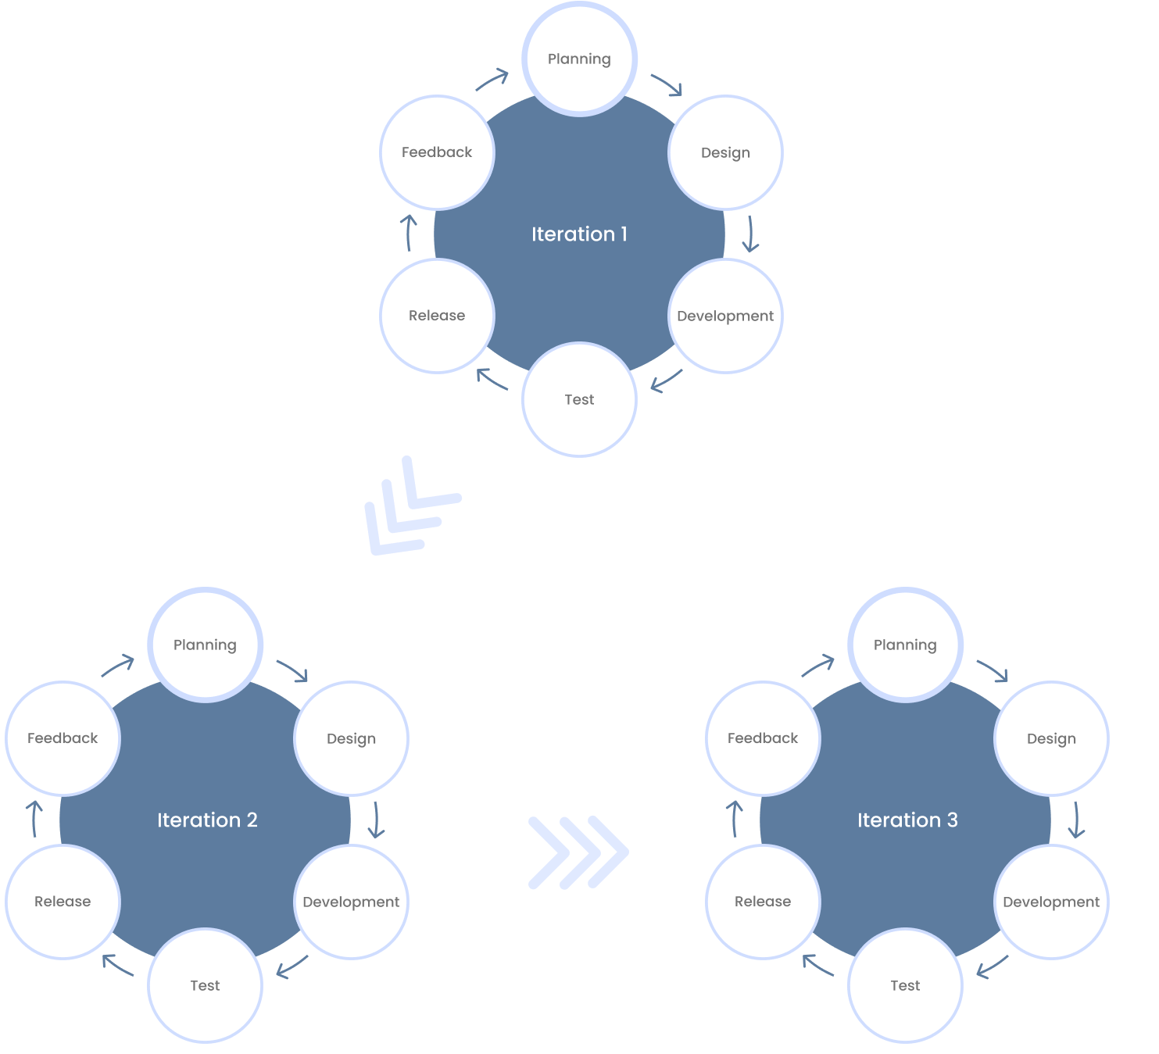

Agile methodology places a strong emphasis on adaptability, client collaboration, and iterative development, it is especially well-suited for a job portal system. Agile's iterative methodology enables the system to be developed in incremental steps, which is advantageous in the context of an online job portal, which frequently needs regular updates and additions to satisfy changing market demands and user expectations. This implies that features may be changed, added, or eliminated in response to immediate input from recruiters, users, and other stakeholders.

**Model Phase**

**Planning Phase**

During this phase of our study, our team will cooperate and collaborate to develop interesting ideas for our chosen model regarding the current traditional ways of handling applications and providing job opportunities, we have found out that it should involve the establishment of an Online Job Portal within the vicinity of Bago City. This system can cater online applications and job inquiries digitally.

In developing this project, each member of the team have prepared their own required devices such as phones and laptops which are vital for coding and the design of our system. These are needed to facilitate the developing process of this whole study.

**Design Phase**

During the design phase of our Agile development process, our team will focus on translating the conceptual ideas outlined in the Planning Phase into a more concrete plan for the implementation of the "Bago City Online Job with Smart Recommendation and Geospatial Analysis" system.

Choosing the right development tools and environments needed for design activities, such as IDEs, version control systems, and collaboration platforms to configure and set up these tools to streamline the design and development process.

Creating wireframes or mockups of the user interface to visualize the layout, navigation, and interactions of the system. Conduct usability testing and gather feedback from stakeholders to iteratively refine the design. Throughout the Design Phase, our team will maintain regular communication and collaboration to ensure alignment with the project objectives and adapt to any changes or insights that may arise. By following an iterative and incremental approach, we aim to produce a robust design that lays the foundation for successful implementation.

**Development Phase**

In our development phase we will collaborate and exchange ideas while working on our system. Addressing inefficiencies in traditional job application processes and availability. We will also create a user-friendly interface in regards to our iterated and final structure of wireframes.

Our team will proceed to undergo with the integration of smart recommendation algorithms and implement geospatial analysis features as well as predictive analysis mechanism based on our set guidelines, processes and objectives to follow.

**Test Phase**

During the Test Phase of our Agile development process, our team will validate and verify the functionalities and features developed in our system. Developing comprehensive test cases based on the user stories defined in the Design Phase and ensure that test cases cover all aspects of the system, including functional, non-functional, and edge cases.

Setting up our testing environment, including configuring test servers, databases, and any necessary testing tools or frameworks to ensure that the testing environment accurately reflects the production environment to facilitate realistic testing scenarios.

Execute the test cases against the implemented features to identify any defects, bugs, or inconsistencies and perform various types of testing, such as unit testing, integration testing, system testing, and acceptance testing, to validate different levels of functionality.

Documentation of any defects or issues encountered during testing. Prioritize defects based on their severity and impact on the system's functionality

and usability then evaluate the performance and scalability of the system under different load conditions and usage scenarios.

**Release Phase**

The Release Phase in our Agile development process involves preparing the system for deployment and delivering it to end-users. Our steps include creating a deployment plan, testing the release candidate, defining a rollout strategy, executing the deployment, monitoring the system post-release, and celebrating the successful release while reflecting on lessons learned. The focus is on ensuring a smooth transition to the newly established system, addressing any issues promptly, and capturing insights for future improvements.

**Feedback Phase**

In the Feedback Phase of our Agile development process, our team will gather insights and feedback from stakeholders and end-users to iteratively improve the "Bago City Online Job with Smart Recommendation and Geospatial Analysis" system.

During this time we will undergo collection of feedbacks from stakeholders, users, and relevant subject matter experts. We will also utilize various feedback channels such as surveys, interviews, user forums, and feedback forms to gather input to encourage open and honest communication to capture diverse perspectives and insights.

Throughout the Feedback Phase, our team will maintain the commitment to leverage stakeholder and user feedback to drive iterative improvements and deliver a system that meets the evolving needs and expectations of its users. By embracing feedback as a valuable source of insight, we will strive to create a user-centric and responsive solution that delivers maximum value to our stakeholders.

**CHAPTER IV**

**ENVIRONMENTAL CONTEXT**

In the competitive world of online job portals, success transcends simply offering innovative features. It demands a deep understanding of the existing environment, a complex web of factors that shape how job seekers and employers interact within this ecosystem. From the number and type of existing portals shaping the competitive landscape, to the demographics and needs of the user base, and the types of jobs typically posted, a holistic view of this environmental context is crucial. Furthermore, staying ahead of the curve in technological advancements in online recruitment is vital for providing a user experience that meets evolving expectations. By acknowledging and strategically responding to these diverse environmental factors, online job portals can carve their niche within the existing ecosystem, ultimately fostering a more efficient and successful online recruitment landscape.

**Organization**

An online platform is designed to connect job seekers with employers. Such as offering services and tools to help job seekers find employment opportunities and assist employers in finding qualified candidates. They may provide features such as job listings, resume building tools, interview preparation resources, and networking opportunities. The goal of these organizations is to facilitate the job search process and improve the efficiency of matching job seekers with job openings. Strategic planning and resource allocation are facilitated by their improved clarity and grasp of the job portal structure. The organizational chart is shown below:

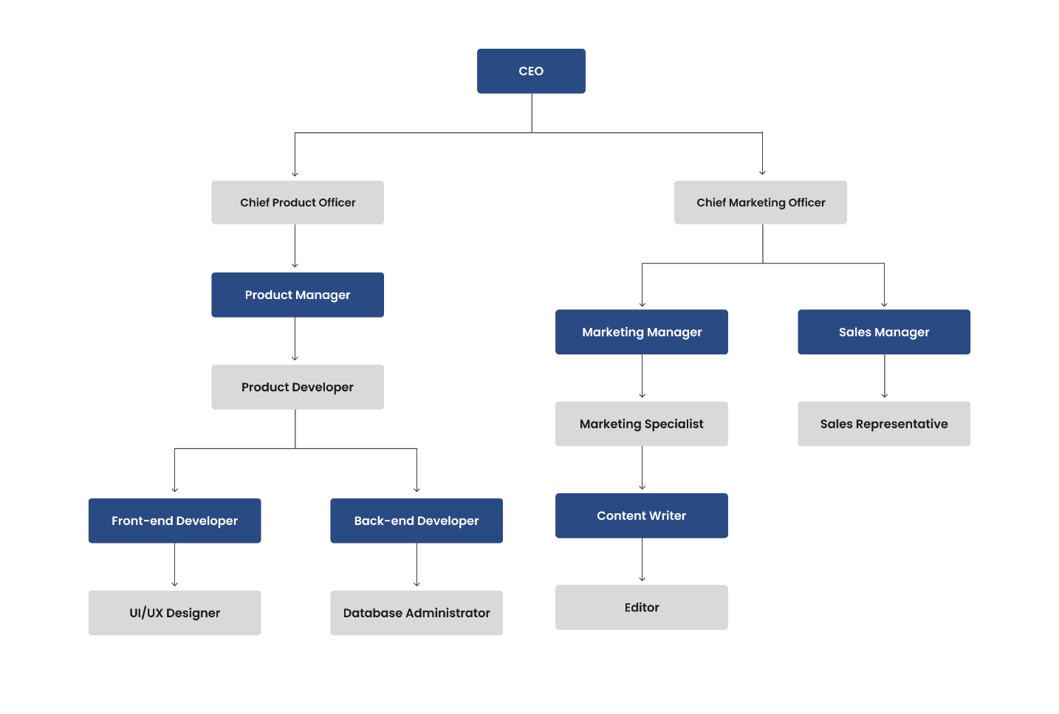

**CEO (Chief Executive Officer)**

The CEO is the highest-ranking executive in a company. They are responsible for making major corporate decisions and managing the overall operations and resources of the company.

**Chief Marketing Officer**

The Chief Marketing Officer is responsible for developing and executing the company's marketing strategy. They work closely with the Product Manager and Marketing Manager to ensure that the company's products and services are effectively marketed to its target audience.

**Product Manager**

The Product Manager manages the development and launch of new products. They work closely with the Product Developer, UI/UX Designer, and other team members to ensure that the product meets the needs of its target audience and aligns with the company's overall business goals.

**Marketing Manager**

The Marketing Manager does day-to-day marketing activities of the company. They work closely with the Content Writer, Marketing Specialist, and other team members to develop and execute marketing campaigns that promote the company's products and services.

**Sales Manager**

The Sales Manager is utilizes and manages the sales team in developing sales strategies to increase revenue. They work closely with the Sales Representative to ensure that the company's products and services are effectively sold to customers.

**Product Developer**

The Product Developer designs and develops new products. They work closely with the Product Manager, UI/UX Designer, and other team members to ensure that the product meets the needs of its target audience and aligns with the company's overall business goals.

**Marketing Specialist**

The Marketing Specialist implements marketing campaigns and analyzing their effectiveness. They work closely with the Content Writer, Marketing Manager, and other team members to develop and execute marketing strategies that promote the company's products and services.

**Sales Representative**

The Sales Representative is responsible for selling the company's products and services to customers. They work closely with the Sales Manager to develop and implement sales strategies that increase revenue.

**Content Writer**

The Content Writer creates written content for the company's website, blog, and other marketing materials. They work closely with the Marketing Manager and Marketing Specialist to develop and execute content marketing strategies that promote the company's products and services.

**Front-end Developer**

The Front-end Developer develops the user interface of the company's website and other digital products. They work closely with the UI/UX Designer and Back-end Developer to ensure that the user interface is visually appealing and functional.

**Back-end Developer**

The Back-end Developer develops the server-side logic of the company's website and other digital products. They work closely with the Front-end Developer and Product Developer to ensure that the back-end is stable and secure.

**Editor**

The Editor handles the reviews and edits written content for the company's website, blog, and other marketing materials. They work closely with the Content Writer and Marketing Manager to ensure that the content is high-quality and aligns with the company's brand voice.

**UI/UX Designer**

The UI/UX Designer is the one that designs the user interface and user experience of the company's website and other digital products. They work closely with the Product Developer, Front-end Developer, and other team members to ensure that the user interface is visually appealing and functional.

**Database Administrator**

The Database Administrator manages the company's databases. Working closely with the Back-end Developer and other team members to ensure that the databases are secure, stable, and scalable.

**Processes**

Transactional processes in a job hunt refer to the various steps and interactions involved in finding and securing a job. These processes typically include:

1. **Job Search**

Actively looking for job openings through local job boards, companies, networking, and job fairs.

1. **Resume and Cover Letter Preparation**

Crafting a compelling resume and cover letter tailored to the job you're applying for.

1. **Application Submission**

Applying for jobs by submitting your resume and cover letter through the appropriate channels.

1. **Interviewing**

Participating in interviews, which may include phone screenings, video interviews, and in-person meetings.

1. **Skills Assessment**

Completing assessments or tests to demonstrate your skills and qualifications for the job.

1. **Negotiation**

Negotiating job offers, including salary, benefits, and other terms of employment.

1. **Acceptance and Onboarding**

Accepting a job offer and going through the onboarding process with the new employer.

1. **Post-Interview Follow-Up**

Sending thank-you notes and following up with employers after interviews.

1. **Rejection Handling**

Managing rejection and continuing the job search process.

**Data**

Data encompasses a wide array of information crucial for the platform's operation and effectiveness. This includes user data, comprising details provided by individuals when creating profiles or accounts, such as their name, contact information, work history, skills, and preferences. Submission by users when applying for jobs, such as resumes, cover letters, and responses to application questions. Collecting data through the following document/s:

1. **Resume**

* Often required as part of the job application process. They provide employers with a standardized way to compare the qualifications of different candidates.
* Introduces job seekers to potential employers by providing a summary of work experience, skills, education, and qualifications.
* Resumes can be used to track a candidate's career progression over time. They can also be updated regularly to reflect new skills, experiences, and achievements.

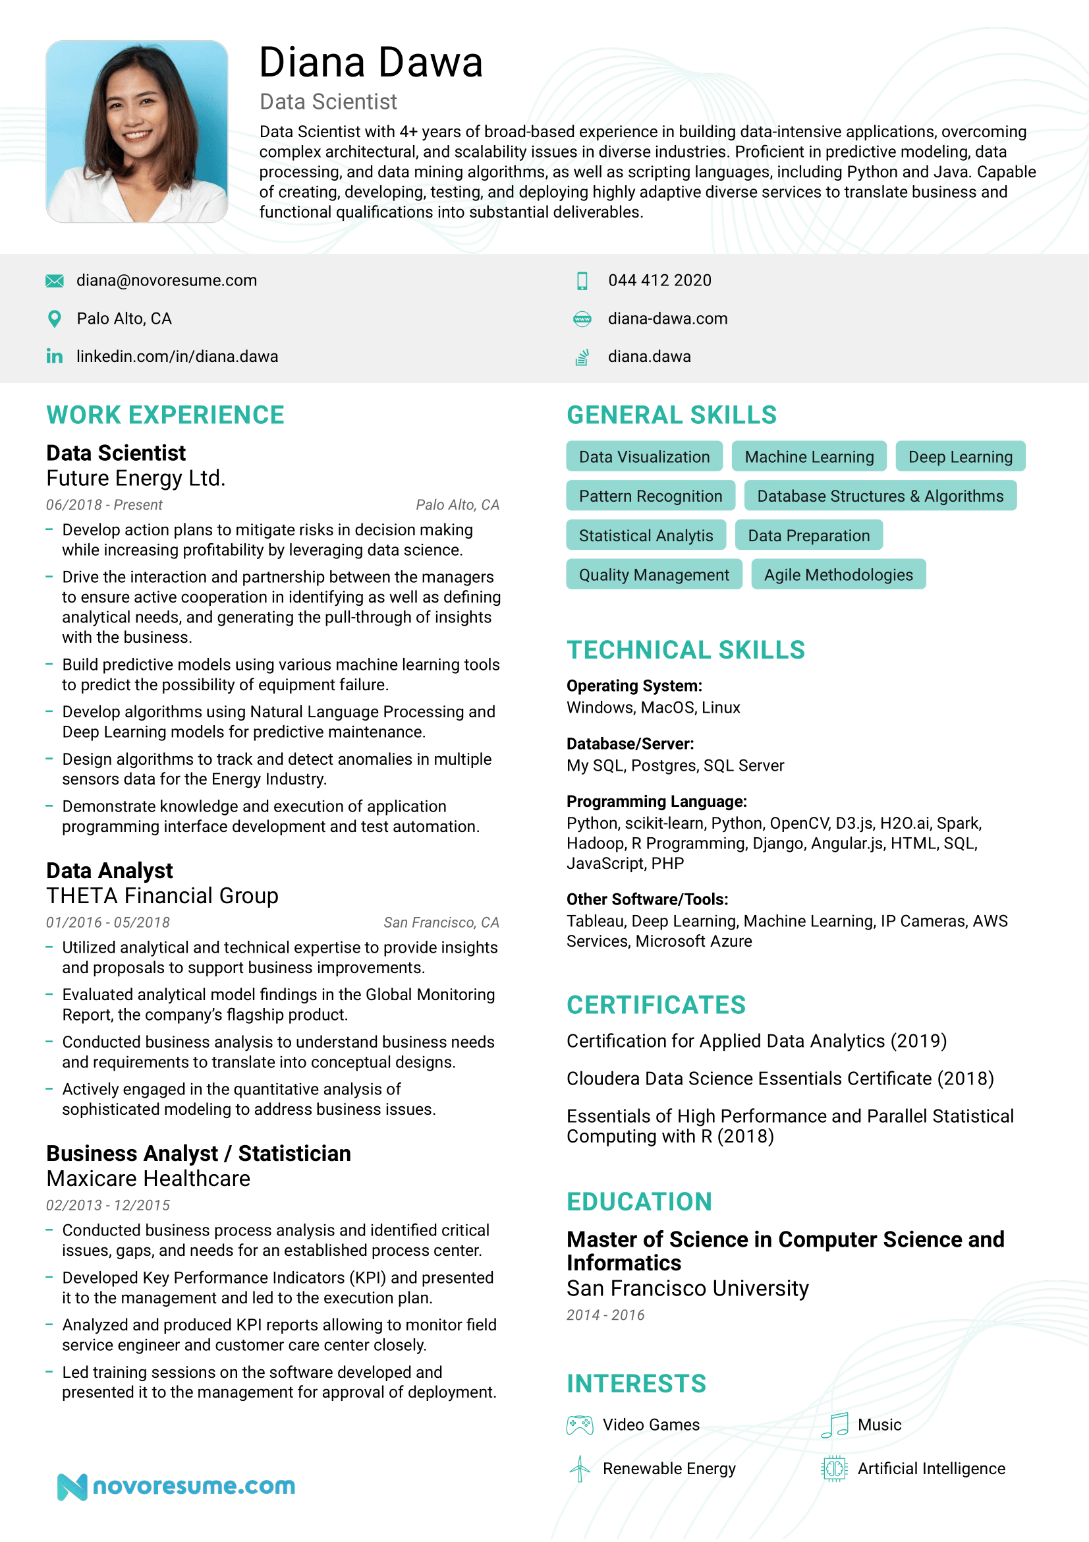

1. **Cover Letters**

* Provides a brief overview of their qualifications and interest in a specific position.
* Opportunity for candidates to showcase their personality and enthusiasm for the position, which can help them stand out from other applicants.
* Can be used to request a specific action, such as requesting an interview or providing additional information.

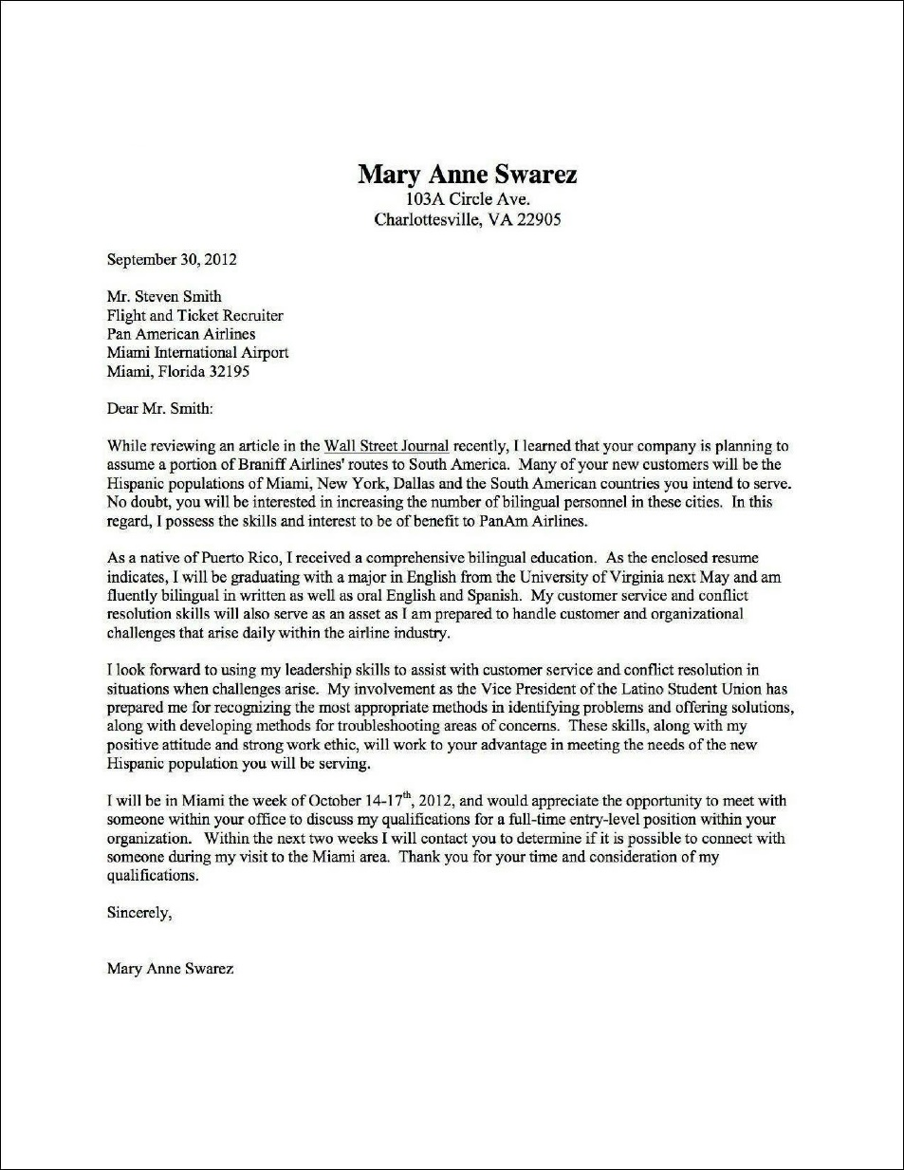

1. **Valid ID**

* IDs are used to verify a person's identity, ensuring that they are who they claim to be.
* ID’s can serve as a solid proof of age.



**Technology**

Manual job systems, especially in the context of recruitment or job matching, typically rely on traditional methods and tools. These can vary depending on the specific system, but some common technologies and practices include:

1. **Paper-based**

Many manual job systems use paper applications, resumes, and job postings. These may be stored in filing cabinets or other physical storage systems.

1. **Spreadsheets**

Some manual systems use spreadsheets to track job openings, applications, and candidate information. This can include using Excel or Google Sheets for data management.

1. **Email**

Email is often used for communication between recruiters, hiring managers, and candidates. It can be used to send job postings, schedule interviews, and follow up with candidates.

1. **Word processing software**

Word processing software like Microsoft Word or Google Docs may be used to create job descriptions, offer letters, and other documents related to the hiring process.

1. **Phone and in-person interviews**

Manual job systems often rely on phone calls and in-person interviews to screen and evaluate candidates.

**Information**

This part of the chapter provides all possible reports giving a comprehensive overview of the Job Portal System's performance. It analyzes key metrics for both job seekers and employers, including user activity, job postings, applications submitted, and overall system effectiveness.

1. **User Activity (Within the past 30 days)**

* **Job Seekers**
* New Registrations: 112
* Active Users: 209
* Average Logins per User: 8
* Resumes Uploaded: 176
* Job Searches Conducted: 351
* **Employers**
* New Company Registrations: 29
* Active Employers: 16
* Job Postings: 23

1. **Job Postings & Applications**

* **Job Openings**
* Total Job Postings (New & Existing): 189
* Average Job Posting Duration: 24 days
* Top 3 Most Popular Job Categories:

1. Technology - 74 postings
2. Healthcare - 69 postings
3. Customer Service - 47 postings

* **Applications**
* Total applications submitted: 412
* Average applications per job posting: 9

1. **System Performance**

* **System Uptime:** 39%
* **Average Response Time:** 2 seconds
* **User Satisfaction Rating (Based on Surveys):** 4 out of 5

1. **Key findings**

* **Demand:** There is a increase in overall job seeker activity on the platform compared to March 1, 2024.
* **Top Job Categories:** The most sought-after job categories are technology, healthcare, customer service. This indicates a high demand for skilled workers in the IT industry.
* **Job Seeker Preferences:** When applying for jobs, candidates prioritize competitive salary, clear career path, work-life balance. This suggests a shift towards evaluating job security and well-being alongside compensation.
* **Mobile Usage:** 68% of job searches are conducted through mobile devices. This highlights the importance of a user-friendly mobile interface, mobile-optimized job postings.

1. **Recommendations**

* Enhancing search filters for job seekers, offering targeted advertising options for employers, implementing new features to improve user engagement.

**CHAPTER V**

**REQUIREMENTS ANALYSIS AND SPECIFICATION**

This chapter focuses on understanding the needs and expectations of the stakeholders and translating them into detailed specifications that will guide the development process. Discussing techniques used to gather requirements, and the specifications derived from the analysis. It will also outline the key features and functionality of the Bago City Online Job Portal with Smart Recommendation and Geospatial Analysis System, based on the requirements identified. By clearly defining them, the development team can ensure that the final system meets the needs and expectations of its users.

**Technical Requirements**

A successful implementation of an Online Job Portal with Smart Recommendation and Geospatial Analysis System requires careful consideration of hardware and software specifications to support the needs of various user roles within the library ecosystem.

**Server**

**Hardware**

|  |  |  |
| --- | --- | --- |
| **Components** | **Minimum Requirements** | **Justification** |
| Processor | Intel Core i2 | For a minimum processor, it can handle the typical workload of a job portal, which includes handling user requests, processing data, and running the application logic. |
| RAM | 32GB | With 80,000-100,000 concurrent users, a minimum of 32 GB of RAM should have enough memory to support the application's data and processes for a heavy user load. |
| Network | Gigabit Ethernet  (LAN) 1 Gbps (Gigabit per second) network connection. | At least a 1 Gbps network connection should be needed to handle the typical traffic for a job portal, including user requests, database queries, and file transfers. |
| Solid State Drive | 512GB | A 512GB SSD should provide enough storage space for the operating system, application files, and any necessary databases for a small to medium-sized job portal. |
| Monitor | Any available Monitor | Displays visual output from the computer, enabling user interaction and content viewing. |
| Mouse | Any available Mouse | Controls the cursor and facilitates navigation and interaction with graphical interfaces. |

|  |  |  |
| --- | --- | --- |
| Keyboard | Any available Keyboard | Used for text input, command entry, and shortcut execution. |

**Server**

**Software**

|  |  |  |
| --- | --- | --- |
| **Components** | **Minimum Requirements** | **Justification** |
| Operating System (OS) | Ubuntu 22.04 LTS | Provides updates and security patches for five years. Ensures that the web server remains secure and up-to-date, which is crucial for hosting a job portal that may contain sensitive information. |
| Browser | Google Chrome, Mozila Firefox, Microsoft Edge | Most commonly used browsers to access websites and links. |
| Xampp | 8.2.12 (Apache, MySQL) | Used to host database and Apache. |

**Hardware**

**User (Admin)**

|  |  |  |
| --- | --- | --- |
| **Components** | **Minimum Requirements** | **Justification** |
| Processor | Intel Core i2 | This processor is capable of handling the typical workload of a job portal, which includes handling user requests, processing data, and running the application logic. |
| RAM | 8GB | A minimum of 8 GB of RAM is recommended for smooth browsing and usage of web applications, including job portals. This amount of memory should provide enough resources to handle multiple tabs and applications running simultaneously. |
| Network | Gigabit Ethernet  (LAN) 1 Gbps (Gigabit per second) network connection. | A standard internet connection with speeds of at least 1 Mbps (Megabit per second) should be sufficient for accessing, managing a job portal. |
| Hard Disk Drive | 512GB | 512GB HDD offers sufficient storage space for storing operating system files, software applications, documents, and other data. |
| Monitor | Any available Monitor | Displays visual output from the computer, enabling user interaction and content viewing. |
| Mouse | Any available Mouse | Controls the cursor and facilitates navigation and interaction with graphical interfaces. |
| Keyboard | Any available Keyboard | Used for text input, command entry, and shortcut execution. |

**Software**

**User (Admin)**

|  |  |  |
| --- | --- | --- |
| **Components** | **Minimum Requirements** | **Justification** |
| Operating System (OS) | Windows 10 | Compatible with a wide range of software and applications. This makes it easier to develop, deploy, and maintain a job portal on a Windows 10 system. |
| Browser | Google Chrome, Mozilla Firefox, Microsoft Edge | Most commonly used and popular choices for managing job portals due to their compatibility, performance, security features, developer tools, and extension |

**Hardware**

**User (Stakeholders)**

|  |  |  |
| --- | --- | --- |
| **Components** | **Minimum Requirements** | **Justification** |
| Processor | Intel Core i2 | This processor is capable of handling the typical workload of a job portal, which includes handling user requests, processing data, and running the application logic. |
| RAM | 4GB | A minimum of 4 GB of RAM is enough for smooth browsing and usage of web applications, including job portals. This amount of memory should provide enough resources to handle multiple tabs and applications running simultaneously. |

|  |  |  |
| --- | --- | --- |
| Network | Gigabit Ethernet  (LAN) 1 Gbps (Gigabit per second) network connection. | A standard internet connection with speeds of at least 1 Mbps (Megabit per second) should be sufficient for accessing, managing a job portal. |
| Hard Disk Drive | 512GB | 512GB HDD offers sufficient storage space for storing operating system files, software applications, documents, and other data. |
| Monitor | Any available Monitor | Displays visual output from the computer, enabling user interaction and content viewing. |
| Mouse | Any available Mouse | Controls the cursor and facilitates navigation and interaction with graphical interfaces. |
| Keyboard | Any available Keyboard | Used for text input, command entry, and shortcut execution. |

**Software**

**User (Stakeholders)**

|  |  |  |
| --- | --- | --- |
| **Components** | **Minimum Requirements** | **Justification** |
| Operating System (OS) | Windows 10 | Compatible with a wide range of software and applications. This makes it easier to develop, deploy, and maintain a job portal on a Windows 10 system. |
| Browser | Google Chrome, Mozila Firefox, Microsoft Edge | Most commonly used and popular choices for managing job portals due to their compatibility, performance, security features, developer tools, and extension |

**System Facilities and Features**

**Admin**

1. Login
2. Dashboard
3. Search
4. Update
5. Delete
6. Transactions
7. User list
8. Managing user accounts and permissions
9. System
10. Monitoring and moderating job listings and user-generated content.
11. Generating reports and analytics on job listings, user activities, etc.
12. Configuring system settings and preferences.
13. Logout

**User (Stakeholders)**

1. Register
2. Login
3. Create Transaction
4. Employer
5. Posting Job Offers.
6. Managing job listings.
7. Communicating through chat features.
8. Managing applicant evaluations.
9. Job Seeker
10. Creating and updating job seeker profile.
11. Searching and applying for a job.
12. Saving job listings.
13. Receiving notifications on application status.
14. Uploading resumes, cover letters, and other relevant   
    documents.
15. Communicating through chat features.
16. Locating and matching job offer location/venue.
17. Logout

**Data Requirements**

Registration Form

1. Name - the applicant’s full name consists of (First name, Middle name, and Last name).

2. Gender – Male or Female.

3. Age – Date of birth.

4. Email – Active email address.

5. Password - User security

6. Resume - showcase qualifications and experiences to potential employers effectively.

7. ID (Identification) - helps enhance security, verify user identities, and ensure compliance with relevant laws and regulations.

8. Facial Recognition - Enhances security by adding an additional layer of authentication. This helps protect user accounts and sensitive information from unauthorized access as well as a form of retrieving a forgotten password.

**Information Requirements**

The following includes all monthly reports that are managed by the Online Job Portal, these are:

1. Job Posting Report - This report provides information on the number of job postings made over a month.
2. User Activity Report - Reports that tracks the activity of users on the portal, such as the number of job searches, job applications, etc.
3. Application Status Report - An overview of the status of job applications, including the number of applications received, processed, and pending.
4. Geospatial Analysis Report – Analysis of job postings and user activity based on geographic location, providing insights into regional job trends and user demographics.
5. User Feedback Report - Collection of feedback from users about their experience with the job portal, including satisfaction levels, suggestions for improvement, and any issues encountered.

**Functional Requirements**

**Admin**

1. Login – Admin needs to login in order to access administrator mode.
2. Dashboard – This is where user activity and all reports can be viewed by the admin.
3. Search – Admin can search for users and existing posts.
4. Update - admin can update his/her credentials.
5. Delete – The admin can remove user accounts.
6. Transactions
7. User List
8. Manages user accounts and permissions.
9. System

i. Monitors and moderates job listings and user-generated   
 content.

ii. Configures the system settings and preferences.

1. Logout – Admin can safely logout from their account.

**User (Stakeholders**

1. Register - Used to create accounts to access the system.
2. Login - Requires the user to enter username and password.
3. Create Transaction.
4. Employer
5. Posting Job Offers.
6. Manages Job Listings.
7. Communicating with job seekers through chat features.
8. Manages candidate evaluation.
9. Job Seeker
10. Creating and updating job seeker profile.
11. Searching for job offers.
12. Saving job listings.
13. Receive notification and status.
14. Uploads resumes, cover letters, and other relevant documents.
15. Communicating with employers/recruiter through chat features.
16. Locating and computing employer location/venue.
17. Logout – User can safely logout from their account.

**Management and Support Requirements**

Management and support requirements for a job portal encompass a range of elements essential for its effective operation. Firstly, robust user account management is crucial, ensuring smooth registration, profile creation, and access control. This includes features for account recovery, password management, and ensuring data privacy and security compliance. Additionally, content management tools are vital for administrators to manage job listings, user-generated content, and ensure data accuracy and relevance. Furthermore, a comprehensive support system is essential, including helpdesk functionality, FAQs, and user guides to assist users in navigating the portal and resolving issues.

Regular monitoring and maintenance are also necessary to ensure optimal performance, including database management, server maintenance, and software updates. Lastly, effective communication channels, such as email notifications and messaging systems, are essential for keeping users informed about new job listings, application statuses, and platform updates. Overall, a well-rounded management and support framework is crucial for ensuring the job portal's functionality, security, and user satisfaction.

**CHAPTER VI**

**DESIGN**

This chapter delves into the meticulous process of designing the portal, emphasizing both the aesthetic and functional elements that cater to the diverse needs of job seekers and employers. The chapter details the specific components and modules that constitute the system, including the user interface, backend infrastructure, database management.

We delve into the architecture and structural blueprint of the Bago City Online Job Portal, highlighting technologies employed to create a robust and user-centric platform. We prioritized creating a seamless user experience, ensuring that the platform is not only visually appealing but also easy to navigate.

### **Architectural Design**

Defining the overall organization, patterns, and principles guiding the system's construction and evolution. Architectural design encompasses several key aspects:

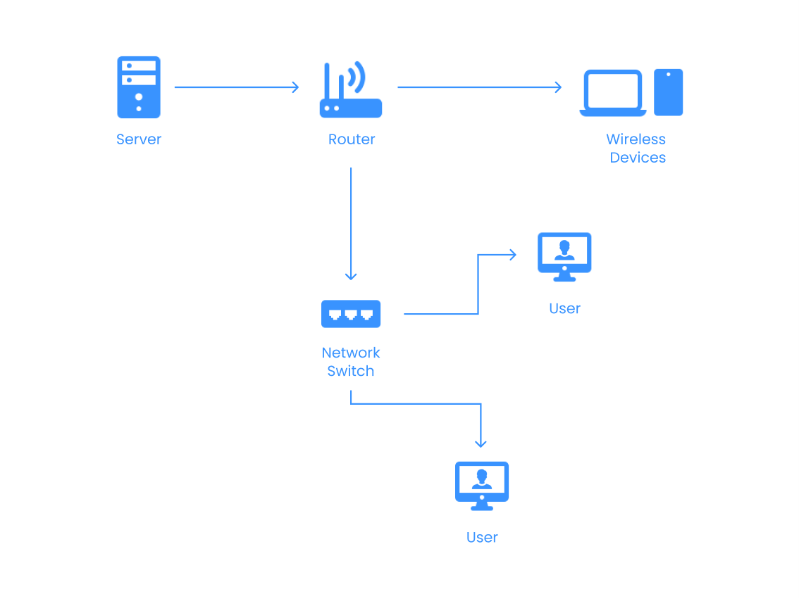

**Process Design**

In the context of an online job portal system, Process design is the art of crafting the steps that connect job seekers with their ideal careers and employers with the perfect talent. It's the roadmap that ensures a seamless experience for both sides, maximizing efficiency and fostering successful connections.

**Use Case Diagram**

A use case diagram visually depicts the interactions between the users (actors) and the functionalities (use cases) of a system. In the context of an online job portal, it helps us understand the key roles (job seekers and employers) and the actions they can perform within the system. Here's a breakdown of a use case diagram for our system:

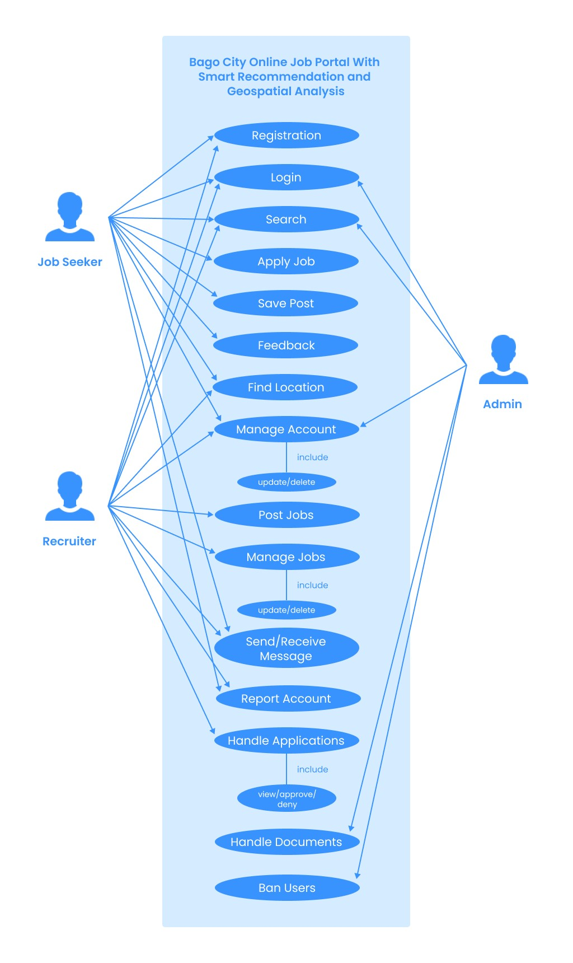

**DFD (Data Flow Diagram)**

An online job portal thrives on the seamless exchange of information between users and the system. This intricate dance of data is captured in a Data Flow Diagram (DFD). It visually depicts the flow of data through the system, helping us understand how information is processed and used.

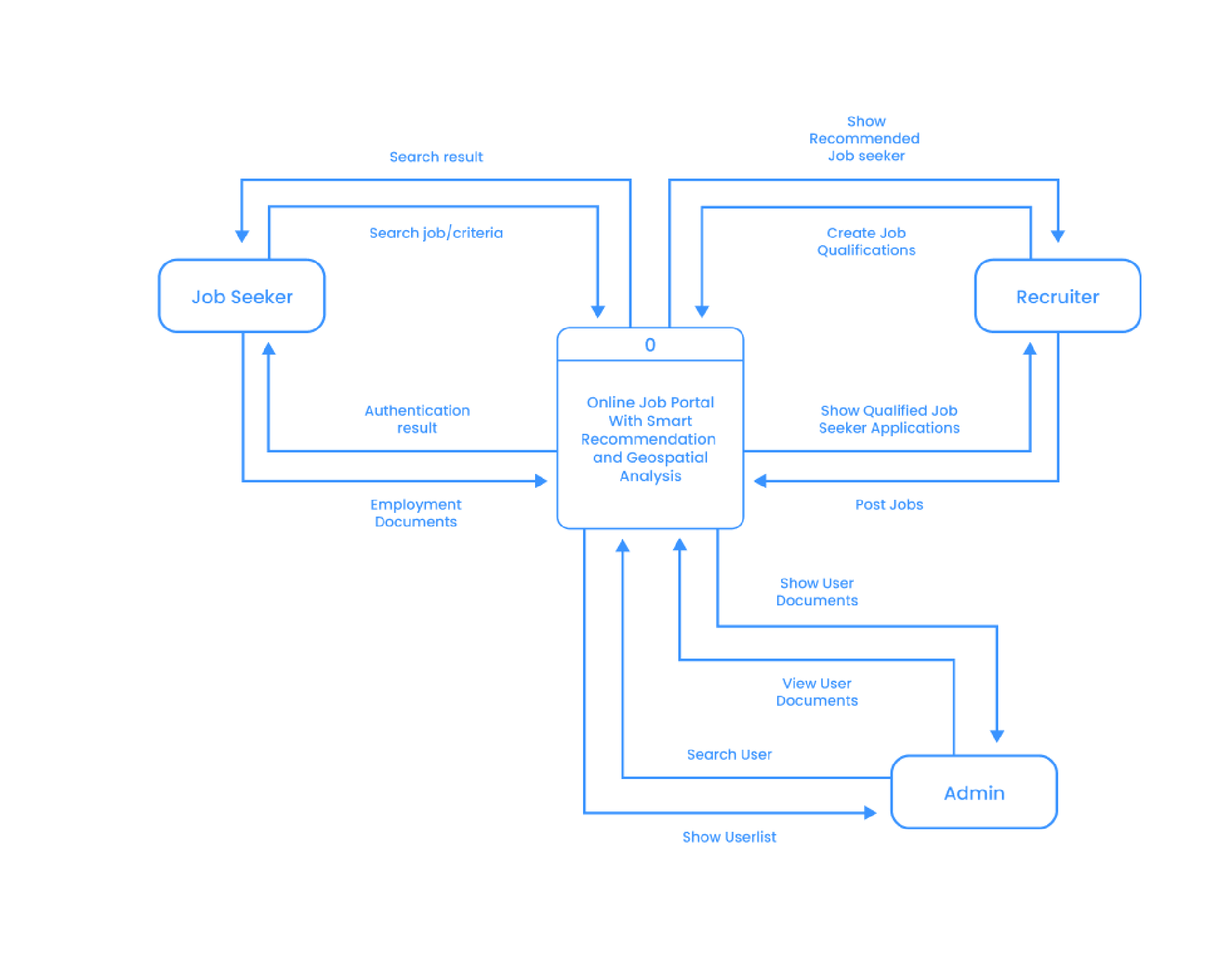

**ERD (Entity Relationship Diagram)**

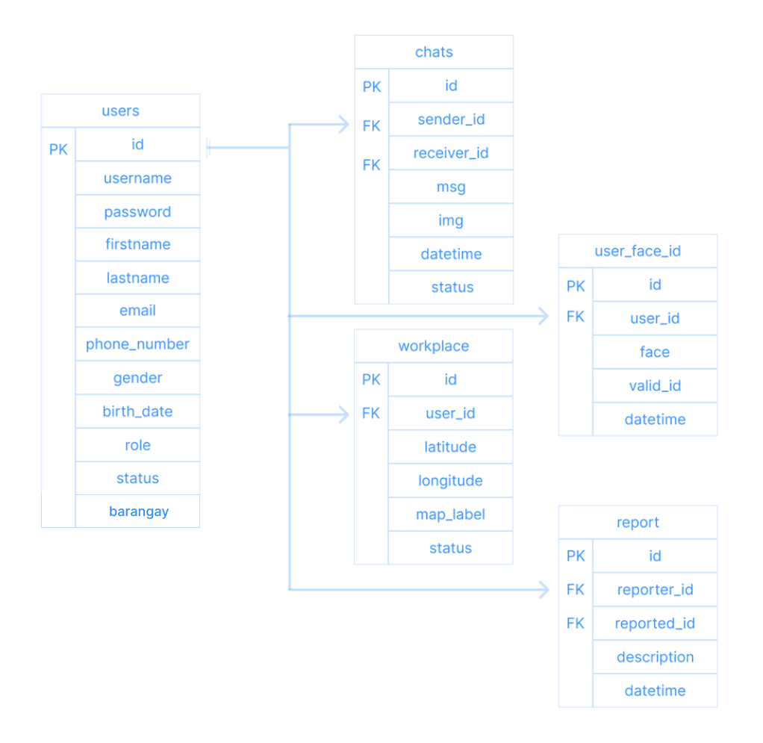 An Entity-Relationship Diagram (ERD) delves deeper than a data flow diagram, focusing on the core entities (data points) within the online job portal system and how they relate to each other. It's like a blueprint for the system's database, ensuring data is organized and retrievable for efficient functioning.

**Database Design**

Beneath the surface lies a complex symphony of data, meticulously organized and efficiently stored. This symphony is orchestrated by the database design, the invisible foundation that empowers the entire system.

USER

|  |  |
| --- | --- |
| NAME | DEFINITION |
| ID | Unique identifier for user this is the primary key |
| USERNAME | Username for user |
| PASSWORD | Password use by user |
| FIRST NAME | First name of the user |
| LAST NAME | Last name of the user |
| ROLE | To identify what their role in the system |
| BIRTHDATE | Refers to a field or column that stores the date of birth of each employee. |
| GENDER | typically stores information about the gender identity of each employee |
| STATUS | Refers to a method of handling the deletion of data from a database without actually removing it permanently. |
| PHONE NUMBER | Active phone number use by the employee use to contact them for emergency. |
| BARANGAY | An address to inform users of your location. |
| EMAIL | Active email use by the employee use to inform them. |

chats

|  |  |
| --- | --- |
| NAME | DEFINITION |
| id | Unique identifier for employee this is the primary key |
| user_id | This field refers to a unique identifier assigned to each individual user. It likely serves as a foreign key linking to another table where user details are stored. |
| receiver_id | This field seems to indicate the recipient of a message or communication. It could also be a reference to another user similar to `user_id`. |
| msg | This field likely stores the content of a  message or communication exchanged between users. |
|  |  |
| datetime | This field stores the date and time when a message was sent or received, or perhaps when a certain action occurred (e.g., logging attendance). |
| status | Refers to a method of handling the deletion of data from a database without actually removing it permanently. |

workplace

|  |  |
| --- | --- |
| NAME | DEFINITION |
| id | Unique identifier for employee this is the primary key |
| user_id | This field refers to a unique identifier assigned to each individual user. |
| latitude | This field stores the geographic latitude coordinates associated with a particular employee or user. Latitude |
|  | specifies the north-south position on the Earth's surface. |
| longitude | This field stores the geographic longitude coordinates associated with a particular employee or user. Longitude specifies the east-west position on the Earth's surface. |
| marked details | This field may store additional information related to a specific location or event marked by the user or employee, possibly in conjunction with the latitude and longitude coordinates. |
| status | Refers to a method of handling the deletion of data from a database without actually removing it permanently. |

Marked layout

|  |  |
| --- | --- |
| NAME | DEFINITION |
| id | Unique identifier for employee this is the primary key |
| user_id | This field refers to a unique identifier assigned to each individual user. |

|  |  |
| --- | --- |
| map_design | This field likely stores information related to the layout or design of a map associated with the employee or user. It could include details such as the visual appearance, arrangement of elements, or customizations specific to that user. |

**Normalization**

|  |  |  |
| --- | --- | --- |
| USERS_TABLE | |  |
| id | 1 | 2 |
| username | jesryl | seeger |
| password | Stupid_love | seeger |
| first name | Jesryl | Seeger |
| last name | Palmes | Perocho |
| Role | admin | user |
| Birthdate | 06/29/02 | 03/30/02 |
| Gender | male | male |
| Status | Active | Deactive/deleted |
| Barangay | Mailum | Poblacion |
| Phone_number | 09789034765 | 09437847959 |
| email | Stupid_love@gmail.com | seeger@gmail.com |

|  |  |  |
| --- | --- | --- |
| User_face_id |  |  |
| id | 1 | 2 |
| user_id | 2 | 1 |
| img | Img_name.png | Img_name.jpg |
| Valid_id | National_id.png | Drivers_license.png |
| datetime | 05:23:24 02:17:54 PM | 05:23:24 02:20:54 PM |

|  |  |  |
| --- | --- | --- |
| chats |  |  |
| id | 1 | 2 |
| user_id | 1 | 2 |
| receiver_id | 2 | 1 |
| msg | pre | Op? |
| Img | Img_name.png | Img_name.jpg |
| datetime | 05:23:24 02:17:54 PM | 05:23:24 02:20:54 PM |
| status | sent | unsent |

|  |  |  |
| --- | --- | --- |
| workplace |  |  |
| id | 1 | 2 |
| user_id | 2 | 1 |
| longitude | 10.582469 | 10.599899 |
| latitude | 122.905170 | 122.928712 |
| label | prince | 7/11 |
| status | display | hidden |

**Users**

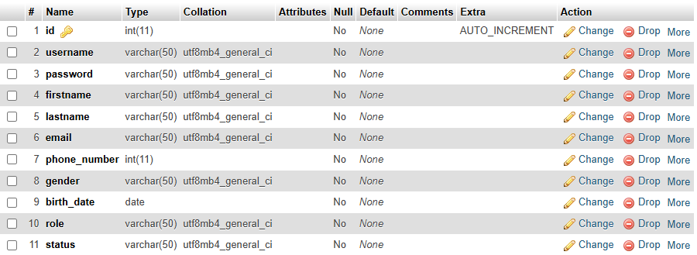

**Chats**

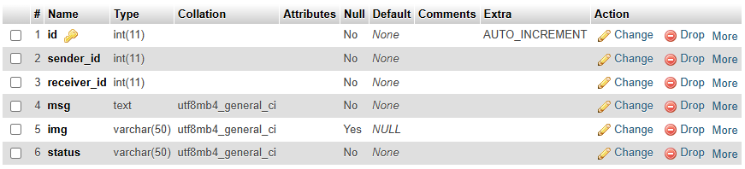

**Workplace**

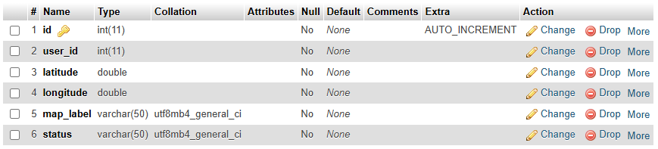

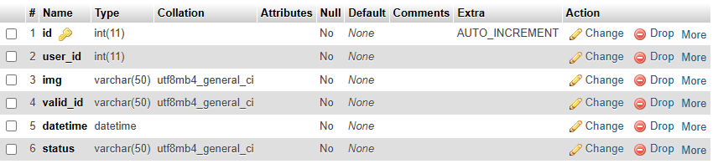**User_face_id**

**Prototype Design**

Before an online job portal goes live, a crucial step lies in crafting its prototype, a preliminary model that showcases its core visuals. It will also serve as our blueprint.

**Landing Page**

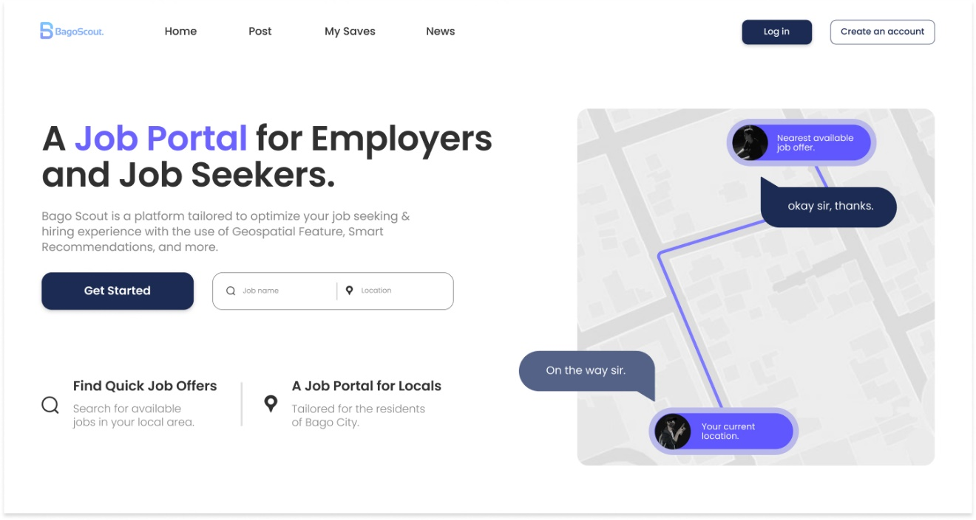

**Login**

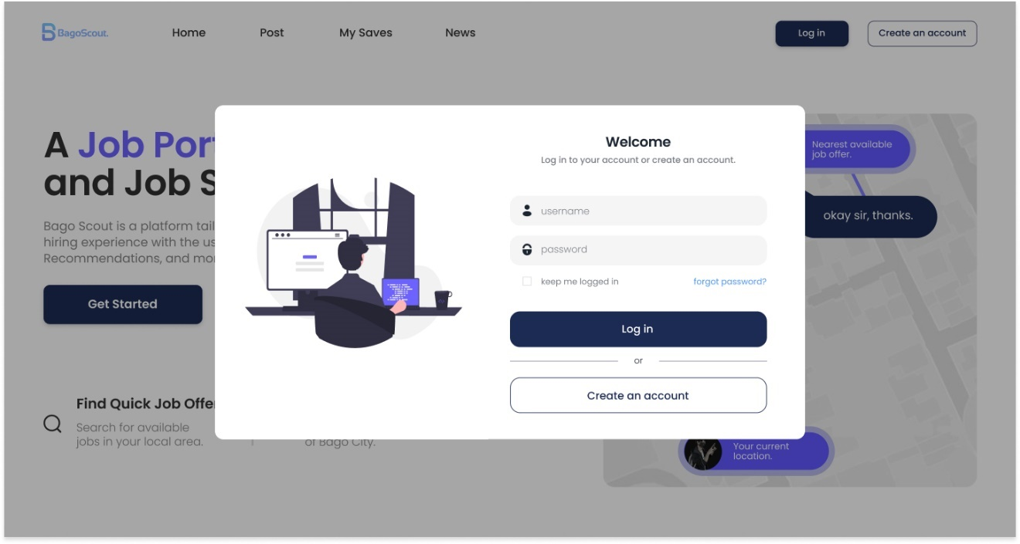

**Register**

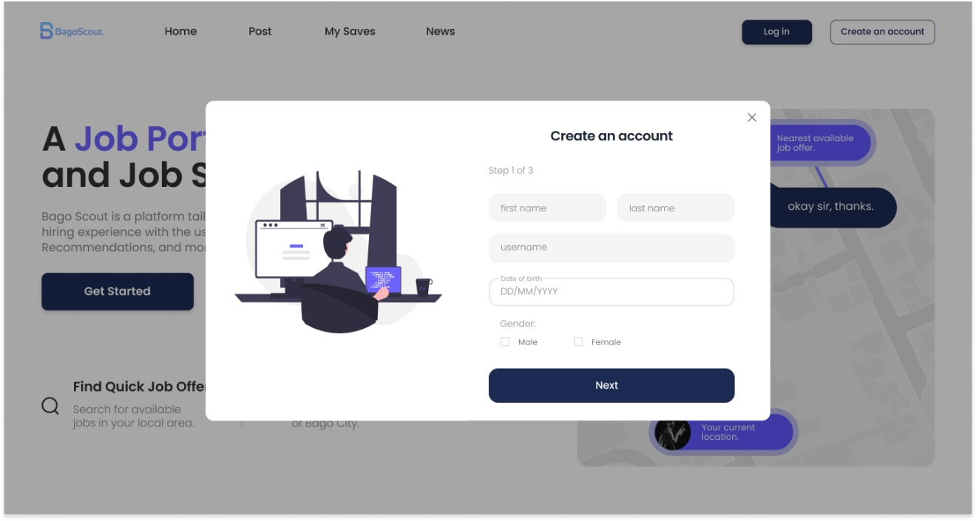

**Home Page**

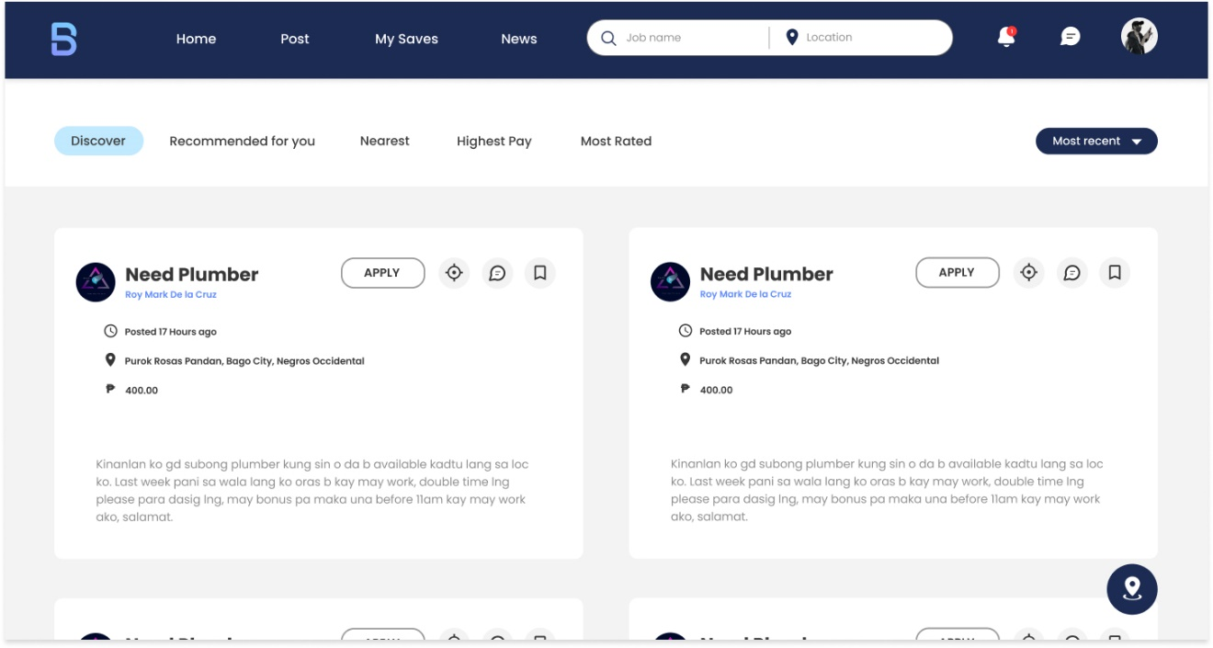

**Post Job**

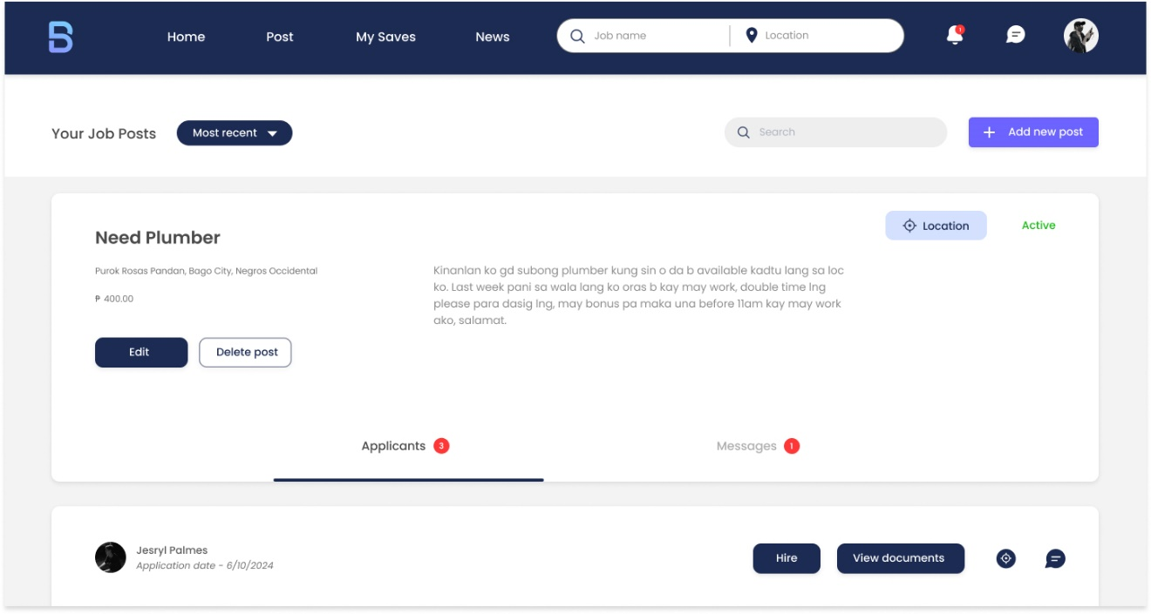

**Chat/Messaging Section**

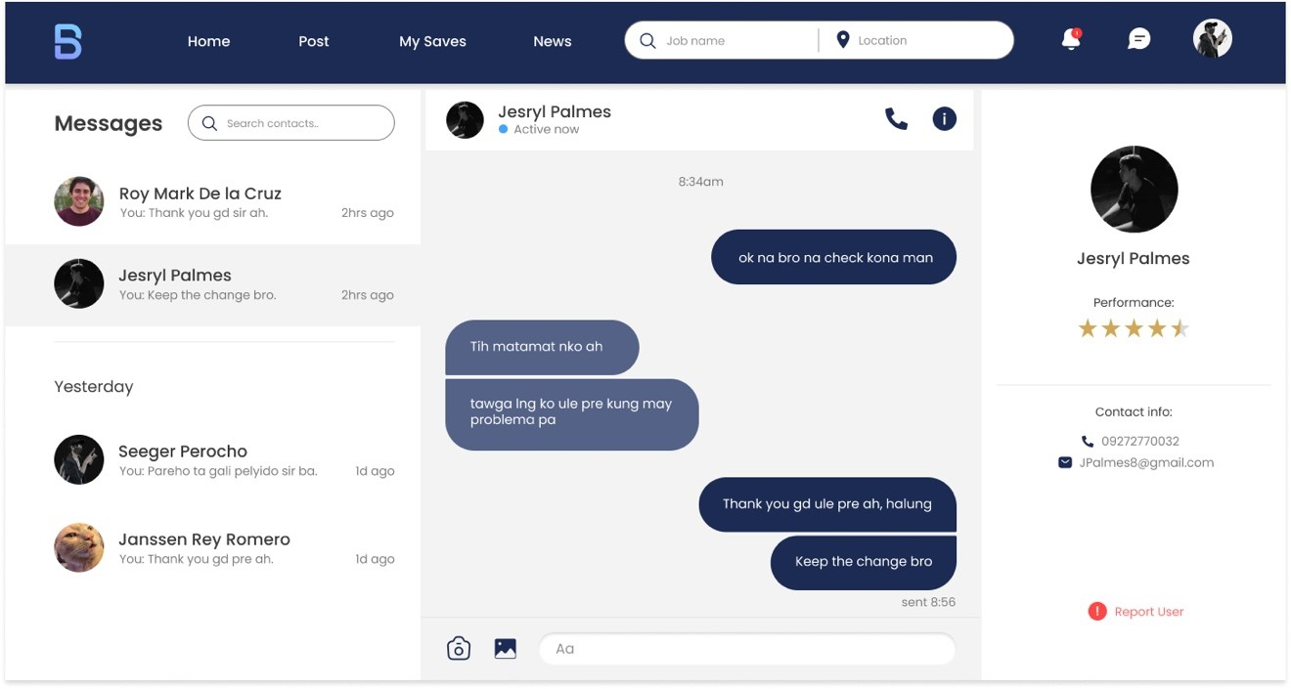

**Manage Account**

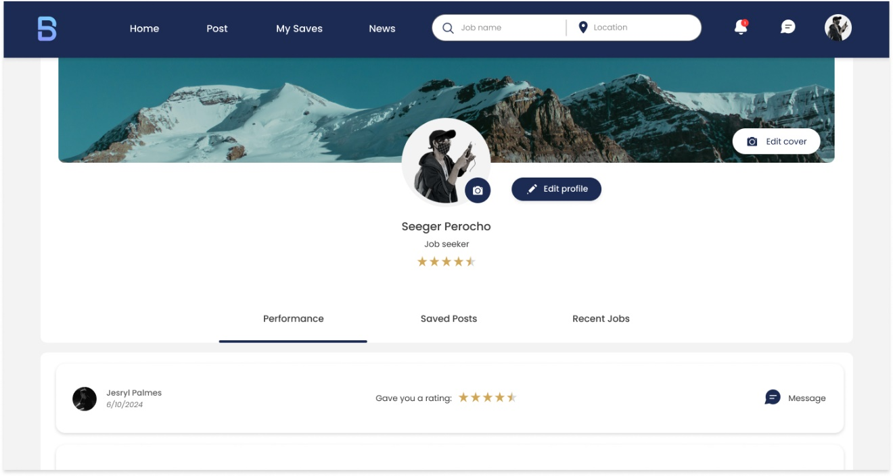

**Map Layout**

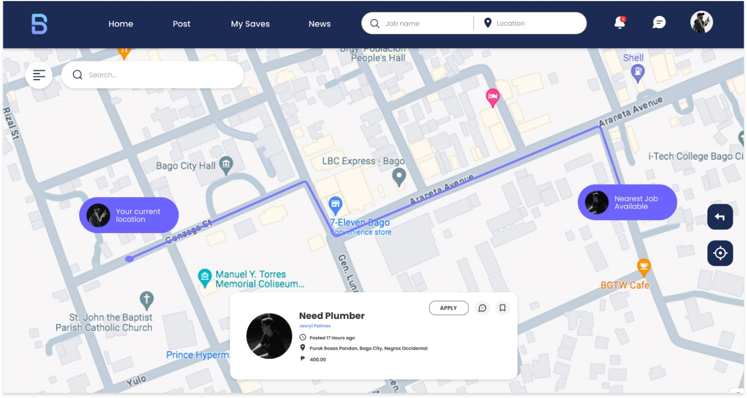

**Map Side Menu**

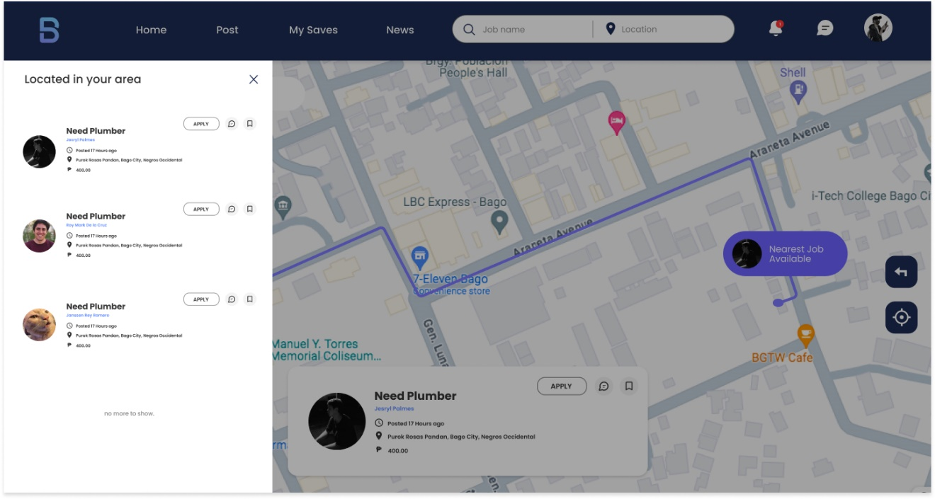

**Admin Dashboard**

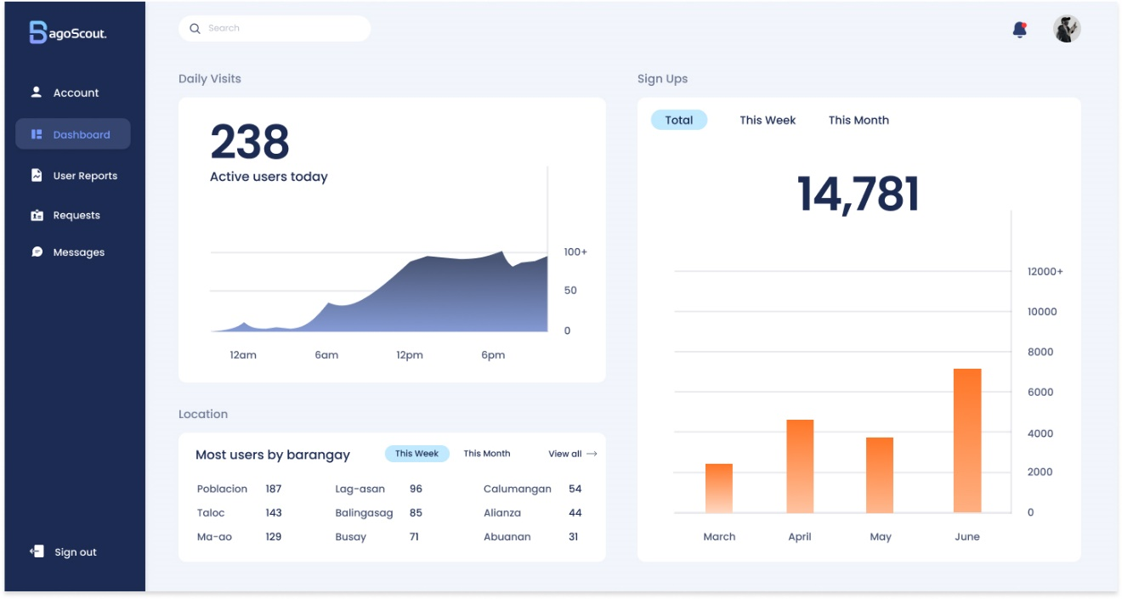

**User Reports**

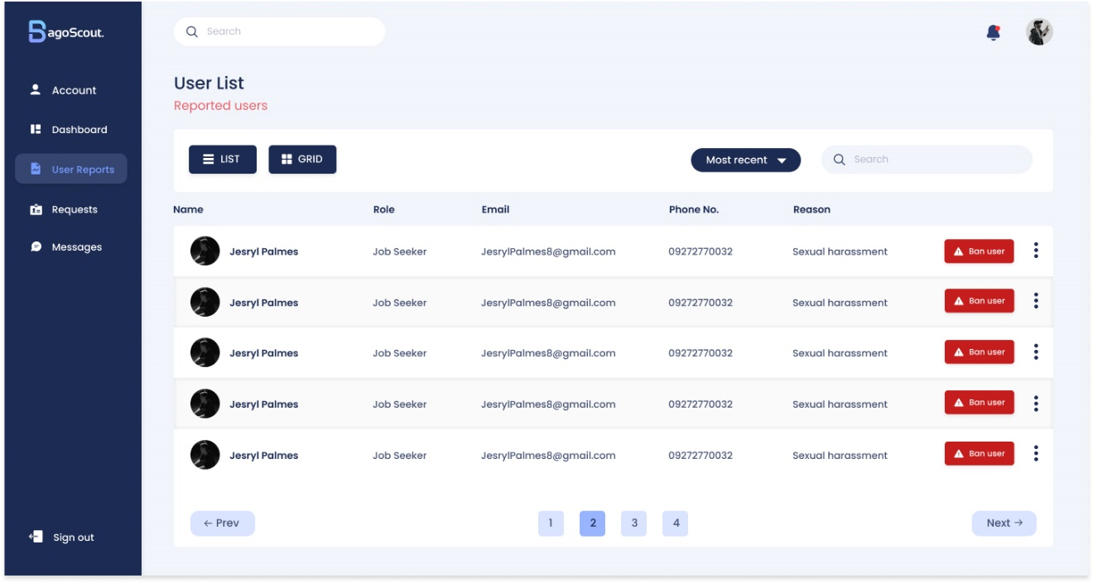

**Requests**

